This document shows you how to change a course term on a course section after students have already been assigned.
Step 1: Go to Home » SIS » Scheduling » Bulk Course Section Management. Enter the course and section number that you need to remove the students from, then press View button.
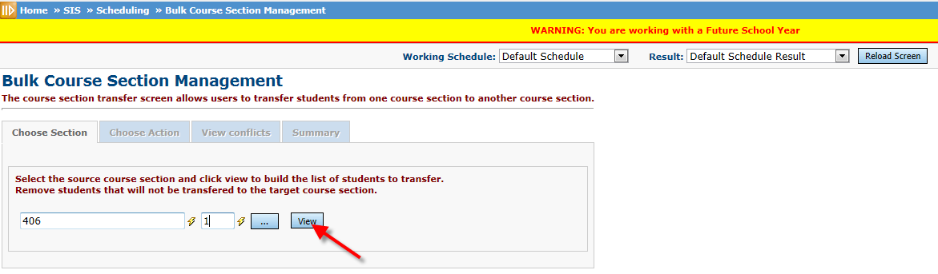
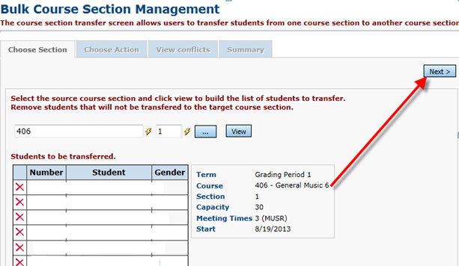
Step 2: This should pull up a list of students in that class, click Next.
Step 3: You will want to click Next on the Chose Action page.
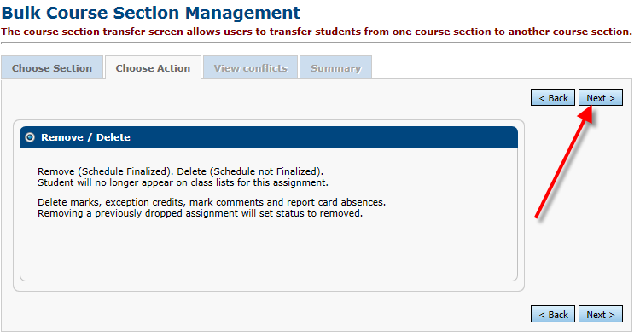

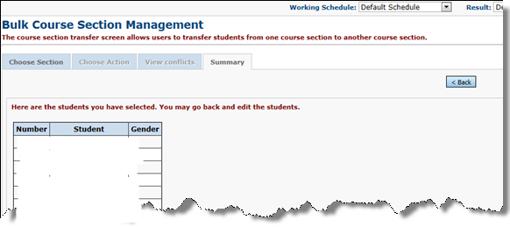
Step 4: The Summary page will show you all of the students and at the bottom of your list; you will want to click Submit. This will take the students out of the section.

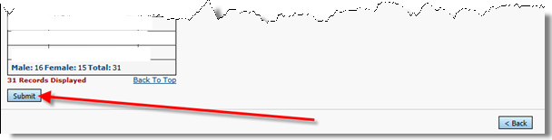

You may want to take note of this list if you want to add these students back to the section after the term is changed.
Step 5: Once the students are removed from the section, you will be able to change the Course Term on the first tab of the course section.
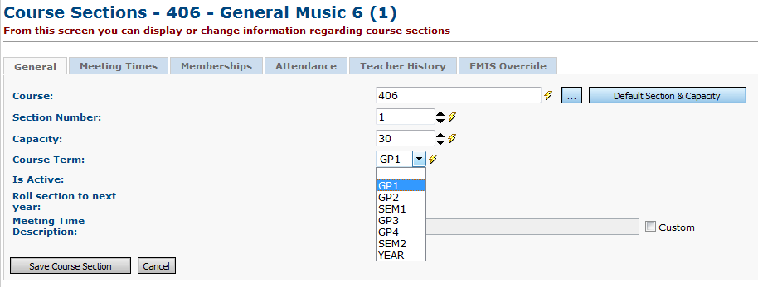

Step 6: You will also want to check the Meeting Times Tab as this will wipe out when you change the Course Term.
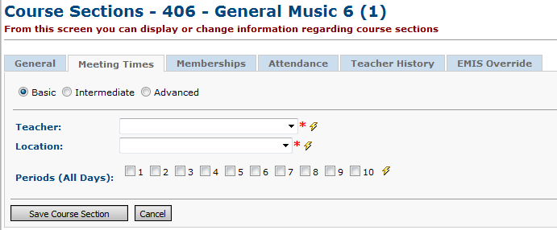

Step 7: Now, you can add the students back to the section if you are wanting too.

